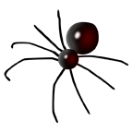Charlotte’s Web of Words
Write the words we have discovered in the sections of the web.

