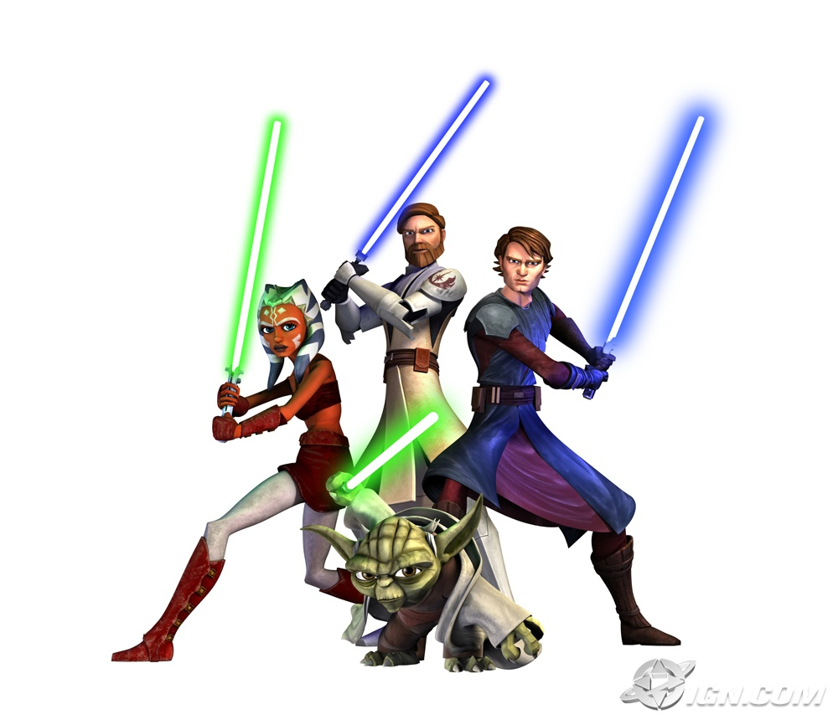
Jedi Mastery: Use the Force
So you want to be a Jedi Master, young padawan?…A Jedi Knight knows that he or she must use the power of the mind to overcome the dark side. This is a club for students who are interested in achieving "above and beyond" the normal classroom expectations. All you have to do earn the title of a Jedi Knight is learn about the topic of your choice, and then turn the answers in to Mrs. Hehman. If you complete all of the challenges of the Jedi trials this school year, you will earn the title of Jedi Master.

A special thanks goes to Mrs. Renz from Redmond, Oregon
for this fabulous idea, click here to see Mrs. Renz's mastery club!
The Jedi Trials |  | The force is strong in this one….

SOCIAL STUDIES |  | Here's a Web Site to Assist You in Your Research.......
1. | Name the 7 continents. | More About the Continents
2. | Name 15 world countries. | Country Maps
3. | Name 15 major world cities. | Capital Cities of the World
4. | Name 15 types of dwellings. | 10 types of dwellings
5. | Name 10 South American and Central American countries. | South America Country Map  Central America Map
6. | Name 10 countries bordering the Pacific Ocean. | Country Maps
7. | Name 10 countries in Europe. | European countries quiz game  Click on the correct European country game
8. | Name 15 historical sites in Rocklin. | City of Rocklin
9. | Name 10 major bodies of water. | Oceans and Seas
10. | Name 10 major world rivers. | Fact Monster - Principal Rivers of the World  River Systems of the World
11. | Name 10 large deserts of the world. | FactMonster deserts of the world  Desert maps
12. | Name 10 large lakes in the North America. | U.S. Lakes.com  Lakes of the world
13. | Name 10 major mountains or mountain ranges. | World Mountain Maps - click a mountain  Highest Peaks
14. | Name the 50 states. | 50 States Quiz
15. | Write the names of the 50 states on a map. | Explore the States
16. | Name the state capitals. | State Capitals - Homework Spot  States & Capitals Game
17. | Name the 13 Colonies. | 13 Colonies Homepage  List of the 13 Colonies  13 Colonies Quiz & Map
18. | Name 10 Native American tribes in California. | Tribal Map
19 | Name 10 California landmarks. | California Landmarks
20. | Name 10 California counties. | California Counties
21. | Name the state symbols of California. | California State Symbols
22. | Name 8 California explorers. | Zoom Explorers
23. | Name 10 California Missions. | California Missions
24. | Name the 1st - 10th presidents in order. | Presidents of the U.S.A.  KidsKonnect - Presidents
25. | Name the last 10 Governors of California . | California Governors
26. | Name 5 American heroes and briefly summarize why they are famous. | American Heroes
27. | Name the symbols of the United States. | U.S. Symbols

SCIENCE |  | Here's a Web Site to Assist You in Your Research.......
28. | Name 15 kinds of fish. | Northeast Fisheries Science Center  KidsKonnect.com - Fish
29. | Name 15 marine creatures. | KidsKonnect.com - Aquariums
30. | Name 15 mammals. | All About Mammals
31. | Name 15 vertebrate animals. | List of vertebrate animals  Vertebrate animals & photos
32. | Name 15 desert animals or wildlife. | Loads of desert animal information
33. | Name 10 amphibians.
34. | Name 10 reptiles. | Reptile Database
35. | Name 10 dinosaurs. | Dinosaur Pictures  KidsKonnect.com - Dinosaurs
36. | Name 10 types of birds. | State Birds of the U.S.A.  KidsKonnect.com - Birds
37. | Name 10 rain forest birds or mammals. | Rainforest Wildlife  Zoobooks - Rainforest Mammals Crossword Puzzle  KidsKonnect.com - Rainforest
38. | Name 10 deciduous trees. | Deciduous Trees  http://www.costumesupercenter.com/csc_inc/html/static/btarticles/fallfoliagephotosandinformation.html
39. | Name 10 rocks or minerals. | Mineral Gallery - see photos  Rock Hounds - How Rocks are Formed  KidsKonnect.com - Rocks & Minerals
40. | Name 10 chemicals and their chemical symbols. | The Periodic Table of Elements  Another Periodic Table Website
41. | Name 10 constellations. | Choose a constellation then "constellation lines"  More constellation pictures  Another constellation site
42. | Name 10 organs in the human body. | Tour of Human Body - Think Quest
43. | Name 8 types of clouds. | More about clouds
44. | Name 5 inventors and their inventions. | National Inventors Hall of Fame Timeline
45. | Name 5 human body systems | Virtual Body
46. | Name the stages of the water cycle. | Brain Pop - Watercycle
47. | Name the order of the colors in the rainbow. | About Rainbows
48. | Label the major bones of the skeleton. | Human Skeleton - Enchanted Learning  Mr. Bones Assembly Activity
49 | Name 5 famous astronauts. | Famous astronauts

LANGUAGE ARTS & LINGUISTICS |  | Here's a Web Site to Assist You in Your Research.......
50. | Name 20 verbs. | What is a Verb?  Play the "Nouns or Verbs? game
51 | Name 20 adjectives. | What is an adjective?  More adjective info.
52. | Name 20 adverbs. | Adverbs  More about Adverbs
53. | Name 15 prepositions. | Guide to Grammar & Writing
54. | Name 10 common nouns & 10 proper nouns. | Nouns  Noun activities to quiz yourself with
55. | Name 10 famous authors. | Children's Authors  KidsKonnect.com - Authors
56. | Give 2 examples each of alliteration, simile, metaphor, and onomatopoeia. | Simile, metaphor,  Onomatopoeia
57. | Count to 20 in Spanish. | Count to 20 & listen
58. | Name 10 popular fairy tales.
59. | Use sign language and "sign" the alphabet. | Animated sign language on the Net  Sign the word you'd like here
60. | List 20 commonly misspelled words.

MATH |  | Here's a Web Site to Assist You in Your Research.......
61. | Draw the lines of symmetry for the capital alphabet. | Symmetry of Capital Letters
62. | Compute area of squares, rectangles, circles, and triangles. | Math.com - Area Formulas
63. | Name the perfect square numbers up to 225. | Learn Your Square Numbers
64. | Write in Roman numerals up to 100. | Roman numerals  Know your Roman numerals  Take a Roman Numerals Interactive Quiz
65. | Name 5 famous mathematicians. | Four famous mathematicians  A long list of mathematicians
66. | Earn 100% on the area & perimeter of rectangles quiz. | Area of rectangles  Play "Shape Surveyor" to practice both  Area & perimeter - under "Free Activities", click "Area" to watch a cool slide show
67. | Earn 100% on the square roots test. | Learn about square roots  Square roots flashcard game
68. | Earn 100% in 4 minutes on the addition basic facts test. | Arithmattack
69. | Earn 100% in 4 minutes on the subtraction basic facts test. | Arithmattack
70. | Earn 100% in 4 minutes on the multiplication basic facts test. | Arithmattack
71. | Earn 100% in 4 minutes on the division basic facts test. | Arithmattack

MISCELLANEOUS |  | Here's a Web Site to Assist You in Your Research.......
72. | Name one career for each letter of the alphabet. | A HUGE list of careers  Jobs Kids Like
73. | Name the birthstones for each month. | Birthstones
74. | Name 10 famous artists.
75. | Name 10 Broadway plays.
76. | Name 15 breeds of dogs. | Dog breeds from A.K.C.
77. | Name 12 winter or summer Olympic events. | KidsKonnect.com - Olympics
78 | List 10 ways kids can help Save the Earth. | Save the Earth
79. | Name 10 instruments in a marching band. | Instrument Encyclopedia
80. | Name 10 instruments in a symphony orchestra. | Sounds from the Orchestra - neat site!
81. | Name 10 football teams and their cities. | National Football League.com
82. | Name 10 Caldecott Award Winning books. | Award Winners
83. | List the 10 most popular girls' and boys' names in the year you were born. | Baby Names
84. | Name 10 National Parks. | National Parks

Mastery Club was created by Heather Renz in Redmond, Oregon.
Permission was granted for use of Mastery Club in our classroom.

